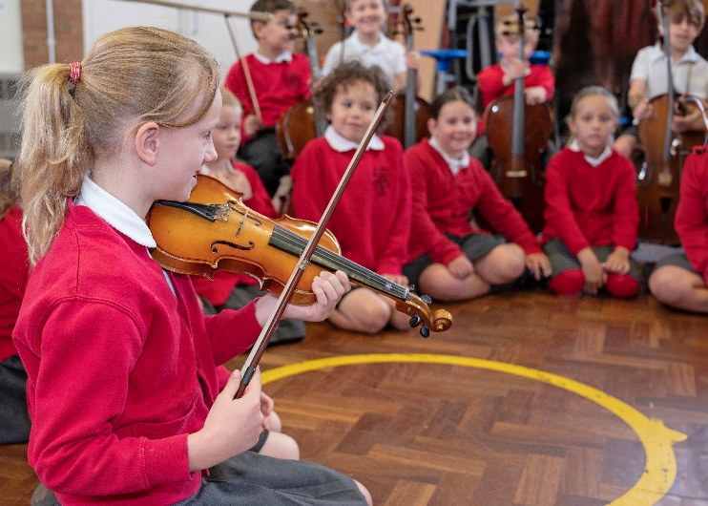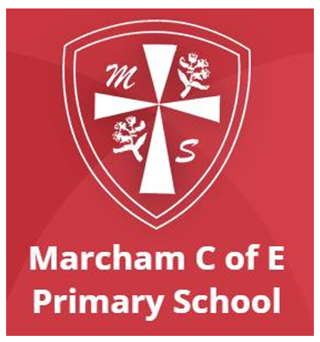
Come and be a part of our Marcham School family.
We pride ourselves on being the primary school for the pupils of Marcham and the surrounding villages and we hope that, meeting us, you will feel that you belong. Come and join us!
Why not visit the school office, phone (01865 391448) or email us office.3235@marcham.oxon,sch.uk for an opportunity to speak to us and arrange to see the school at work. You can also find out more about our school - our vision, values and passions - by visiting our website https://www.marcham.oxon.sch.uk/.
We look forward to welcoming you and showing off what we think is the BEST school in the world! 