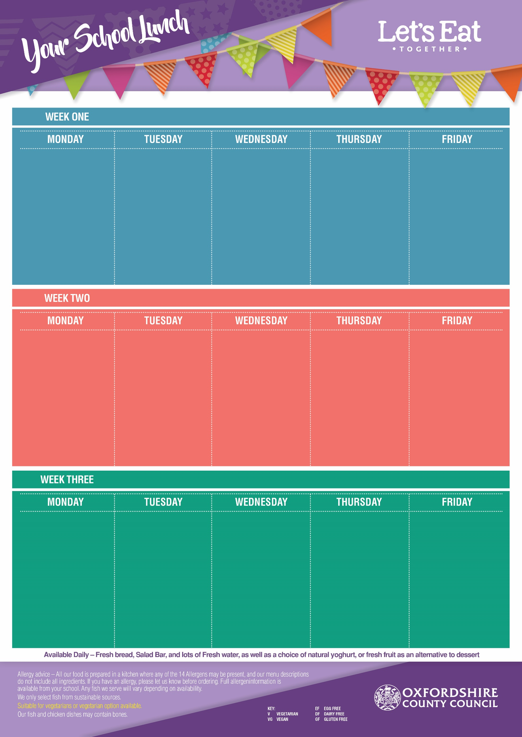
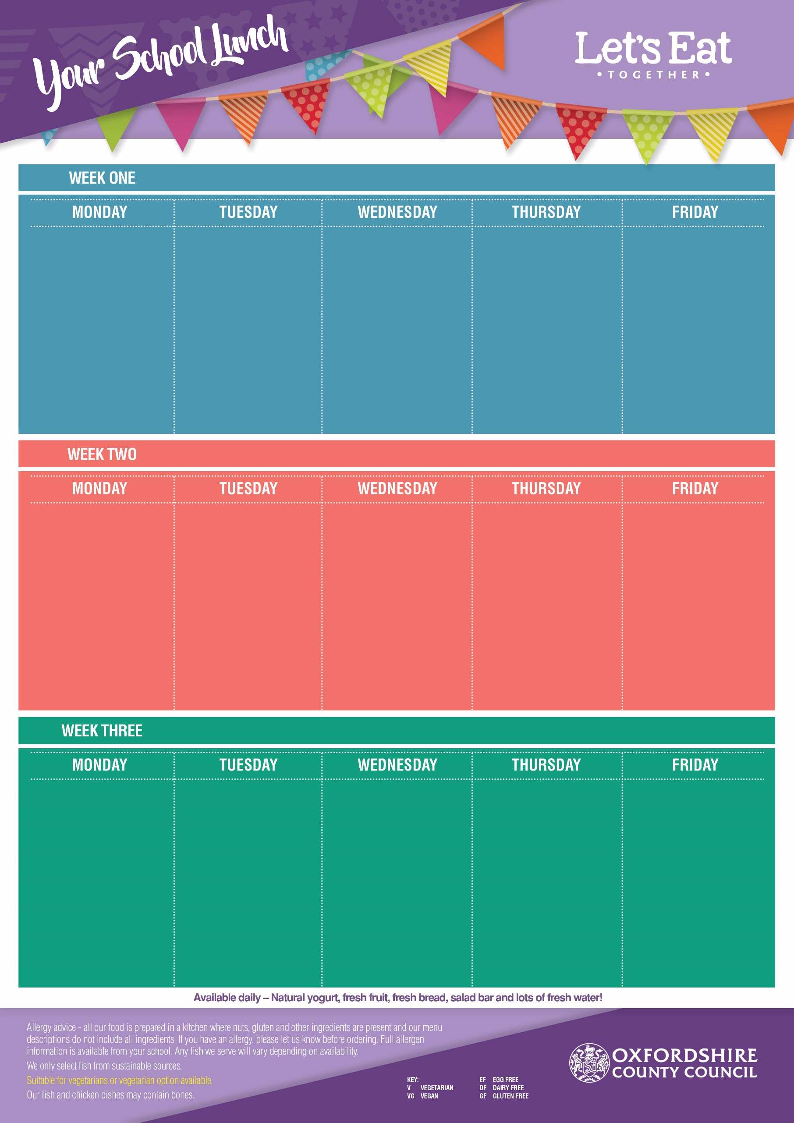
Week Commencing: 16th Nov, 7th Dec, 11th Jan, 1st Feb, 1st March, 22nd March
Week Commencing: 9th Nov, 30th Nov, 4th Jan, 25th Jan, 22nd Feb, 15th March
Week Commencing: 2nd Nov, 23rd Nov, 14th Dec, 18th Jan, 8th Feb, 8th March
Flipper Dippers (DF, EF)
Pizza Pinwheel (V, EF)
Wholemeal Egg Mayo & Lettuce Sandwich (V, DF)

Chips or Pasta
Sweetcorn or
Baked Beans

Vanilla Ice Cream
(V, GF, EF)
with Mandarins

Beef Bolognaise with Twisty Pasta (DF, EF)
Veggie Bolognaise with Twisty Pasta (VG,)

Baked Jacket Potato with Cheese (V, GF, EF) or
Baked Beans (VG, GF)

Carrots & Peas

Iced Sprinkle Cake
(V, DF)

Roast Chicken Breast
(GF, EF, DF)
Vegetarian Quorn Roast
(V, GF)
Tuna & Sweetcorn Pasta Salad (DF, EF)

Roast Potatoes & Yorkshire Pudding with Gravy

Cauliflower
& Green Beans

Lemon Oat Cookie
(V, EF, DF)

Pork Sausages with Gravy (DF, EF)
Veggie Sausage with Gravy (VG, GF)
Jacket Potato with Cheese (V, GF, EF) or Baked Beans (VG, GF)

Mashed Potato, Cabbage & Carrots

Rock Cake (V)
with Melon

Margherita Pizza
(Cheese & Tomato) (V, EF)
Spinach & Pepper Pasta (VG)
Cheese & Cucumber
Wrap (V, EF)

Peas &
Baked Beans

Melting Moment
(V, DF, EF)

Beef Meatballs in Tomato Sauce (GF, DF, EF)
Veggie Meatballs in Tomato Sauce (VG, GF)
Baked Jacket Potato with Cheese (V, GF, EF) or Baked Beans (VG, GF)

Pasta, Sweetcorn & Carrots

Cinnamon Swirl Sponge
(V, DF)

Chicken Nuggets (DF, EF)
Veggie Samosa’s (VG)
Breaded Salmon Wrap with Mayo & Lettuce (EF, DF)

French Fries
or Pasta
Baked Beans
or Peas

Strawberry Jelly
(V, GF, DF, EF)
with Peaches

Cottage Pie
(GF, EF)
Veggie Cottage Pie
(V, EF, GF)
Wholemeal Cheese & Tomato Sandwich (V, EF)

Cauliflower &
Vegetable Medley

Crunchy Cornflake
Cookie
(V, EF, DF)

Sausage Plait (DF)
Crispy Veggie Dippers (VG)
Baked Jacket Potato with Cheese (V, GF, EF) or Baked Beans (VG, GF)

Oven Baked Potato Wedges
Peas & Carrots

Shortbread
(V, EF, DF)
with an Orange Wedge

Margherita Pizza
(Cheese & Tomato) (V, EF)
Mild Mexican Chilli
Loaded Hash Browns
(VG, GF)
Wholemeal Egg Mayo Sandwich (V, DF)

Sweetcorn
& Baked Beans

Vanilla Oat Traybake
(V)

Fish Fingers (DF, EF)
Veggie Sausage Roll (V, EF)
Cheddar Cheese, Tomato & Onion Pasta Salad (EF)

Chips or Pasta
Peas &
Sweetcorn

Strawberry Ice Cream
(V, GF, EF)
with Pineapple

Sticky BBQ Chicken
with Rice (DF, EF, GF)
Mac ’n’ Cheese (V, EF)

Jacket Potato with Cheese (V, GF, EF) or Baked Beans (VG, GF)

Broccoli &
Vegetable Medley

Flapjack
(V, DF, EF)
with Raisins
Roast Loin of Pork
(GF, DF, EF)
Quorn Roast
(V, GF)
Wholemeal Tuna & Cucumber Sandwich (EF, DF)

Roast Potatoes,
Yorkshire Pudding,
Cabbage & Carrots

Chewy Vanilla Cookie
(V, EF)

Cajun Beef & Bean Tortilla (EF)
Cajun Vegetable & Bean Tortilla (V, EF)
Jacket Potato with
Cheese (V, GF, EF) or Baked Beans (VG, GF)

Mixed Salad & Sweetcorn

Lemon Cake
(V, DF)

Margherita Pizza
(Cheese & Tomato)
(V, EF)
Herby Tomato Pasta (VG)
Rainbow Rice Salad (VG)

Peas &
Baked Beans

Ginger
Biscuit
(V, EF, DF)

